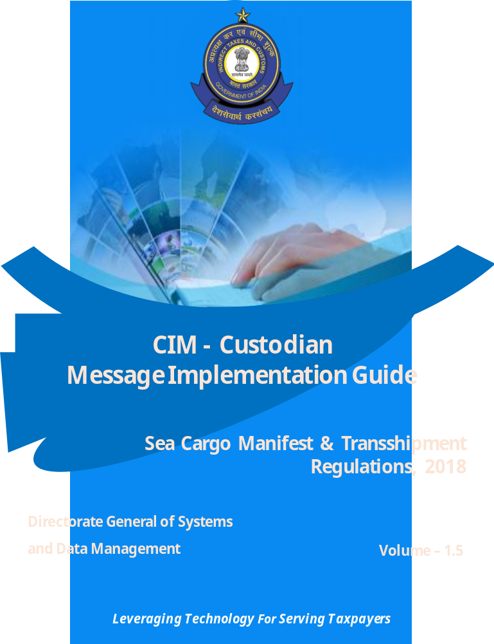

Contents
1. Introduction: 4
1.1 Background: 4
1.2 Scope: 4
1.3 Stakeholders involved: 5
2. Message Guidelines: 5
2.1 Introduction 5
2.2 Submission of the File – ICEGATE: 5
2.3 Acknowledgement of the Declaration: 6
2.3.1 Structural Validation 6
2.3.1.1 Structural Validation File naming format: 6
2.3.1.2 Vocabulary for errors on Structural Validation failure: 6
2.3.1.3 Sample SFL Outbound Files : 7
2.3.2 Business Validation Acknowledgement: 8
2.3.2.1 Business Validation Acknowledgement File Format : 8
3. Process Flow - Sea Terminal Operator: 9
4. Manifest Master Object 9
4.1 JSON Objects: 9
4.2 Structure – Hierarchy: 10
4.3 Attribute Table – Common structure 11
4.3.1 Manifest Master: Declaration 11
4.3.2 Manifest Master: CIM 13
4.3.3 Manifest Master: Location 14
4.3.4 Manifest Master: Transport Means 16
4.3.5 Manifest Master: Events 17
4.3.6 Manifest Master: Cargo Container 19
4.3.7 Manifest Master: Cargo Details 22
4.3.8 Manifest Master: Supporting Document 26
4.3.9 Manifest Master: DigiSign 27
5. Object Attribute Table 28
6. JSON Schema and Samples 30
6.1 Inbound JSON Schema 30
6.2 Inbound JSON Samples 30
6.3 Outbound SFL JSON Schema 30
6.4 Outbound SFL JSON Samples 30
6.5 Outbound ACK JSON Schema 30
6.6 Outbound ACK JSON Samples 30
7. List of Values 32
8. Error Code List 36
9. Key Fields Table for Outbound File 38

Revision History

Version | Date | Owner | Comments
Custodian Message Implementation Guide V 0.1 | 10/08/2019 | ICES
Custodian Message Implementation Guide V 0.2 | 22/08/2019 | ICES
Custodian Message Implementation Guide V 0.3 | 30/09/2019 | ICES
Custodian Message Implementation Guide V 1 | 13/11/2019 | ICES | Updated with  : indication for list of values, camel case for each attribute of table
Custodian Message Implementation Guide V 1.1 | 29/11/2019 | ICES | Updated with: Error Code List, Object Attributes Table
Custodian Message Implementation Guide V 1.2 | 09/12/2019 | ICES | Updated with: Key Field Table for Outbound, Schema attribute name as per updated CSN JSON Schema
Custodian Message Implementation Guide V 1.3 | 17/01/2020 | ICES | Updated with revised Inbound JSON Schema
Custodian Message Implementation Guide V 1.4 | 17/08/2020 | ICES | Updated with revised Error Code List, JSON Schema & Sample and Field Table
Custodian Message Implementation Guide V 1.5 | 06/01/2026 | ICES | Updated Error message for CDB16

Introduction:

Background:
Central Board of Indirect Taxes and Custom (CBIC) vide notification No. 38/2018-Cus (NT)dated 11.05.2018 read with notification No. 65/2018-Cus (NT) dated 30.07.2018 and 88/2018-Cus(NT) dated 30.10.2018 notified Sea Cargo Manifest and Transshipment Regulations 2018.
This regulation supersedes the earlier regulations of Import Manifest (Vessels) Regulations, 1971, Export Manifest (Vessels) Regulation, 1976 and Transportation of Goods (Through Foreign Territory) Regulations of 1965. The new regulation stipulates changes in timelines and requirements for advance notice by shipping lines (vessels) arriving in India and Exports through shipping lines (vessels) out of India.
As per the new regulations, the Authorized Sea Carrier (ASC)/Authorized Sea Agent (ASA) shall submit an Arrival Manifest electronically, prior to departure from the last port of call to the Indian Port of call. And submit a Departure Manifest electronically before departure from the Indian Port of call.
The submission of Arrival and Departure Manifest shall have to be complied with by the ASC/ASA before departure from the last port/customs station of call to every Indian customs station and Departure then on respectively.
In addition, the responsibility is also entrusted with various stakeholders authorized under Handling of Cargo in Customs Inland Station. In case of Export, Stuffing or Stripping report generated after filing Shipping Bill by custodian at Export Departure and in case of Import, Stuffing or Stripping report generated by custodian at Import Departure.

1.2 Scope:
The Scope of this document is to provide list of messages involved in this carrying out above stated responsibility by Terminal operators and provide format, sample for such communication. The brief of messages are as follows:
CIM: Customs Inland Manifest
CIM – SF: Stuffing Report
CIM – SFCN Stuffing Cancellation
CIM – ST: Stripping Report
CIM – DT: Departure Time Notification
CIM – AT: Arrival Time Notification
CIM – CC: Customs to Custodian Notification

1.3 Stakeholders involved:
Following Stakeholders are involved in the implementation
- Authorized Sea Carrier (Including Shipping line)
- Inland Custom Station Operators
- Terminal Operator
- Custom Officers
- Transhipper Custodian
- Authorized Persons of all the above

Message Guidelines:

2.1 Introduction
This message guideline would help the users to prepare the declaration in the required format. The users can either utilize the data already available in the internal systems to generate this declaration in the required format by modifying their internal software systems or use an Excel/Json utility provided by CBIC/NIC in this regard. (The link for Java Utility is - http://ices.nic.in/ices/cim).

The following sections may be referred for the preparation of the file.

- The structure and Hierarchy of the json object is available in Section – 4.2 of this document.
- The attributes of the json objects for different messages is provided in Section - 5.
- The Schema and Sample Json formats are available in Section - 6.
- Certain data elements are coded for bringing uniformity in the processing. The List of values for those data elements are given in Section - 7.
- The file submitted to the ICEGATE should be in following name format. For e.g
F_CUCHE01_SF_ICEGATEID_7031_20200110_DEC.json
(<messageType><msgID><reportingEvent><SenderID><jobID><date>_declaration)
The latest version is always available at the following link (https://www.icegate.gov.in/SeaManifestRegulation.html)

Stuffing Approval messages provided to the Custodian through registered MFTP:

Once SF Message is filed successfully, it will be routed to the Customs Officer for approval. The approval confirmation will be communicated by the Customs System in another ACK. The Approval ACK will have predefined filename format. A sample ACK file has also been included in the document under JSOn File section of this document.

Stuffing Cancellation (SFCN) messages provided by the Custodian through registered MFTP:

The Stuffing details provided by the registered ACU through SF JSON files stuffing file, can be cancelled through stuffing Cancellation message (SFCN). The message workflow is similar as per the Stuffing and SF approval process.

For SFCN, Custodian shall submit Stuffing Cancellation through SFCN through registered MFTP and post successful integration of SFCN request files in customs application, the container is visible to the officer screen under Exam Superintendent Role.

The file submitted to the ICEGATE should be in following name format. For e.g

F_CUCHE01_SFCN_ICEGATEID_7031_20200110_DEC.json
(<messageType><msgID><reportingEvent><SenderID><jobID><date>_declaration)

the fields required for the message has been captured in attribute table along with the Schema & Sample JSON of this document..(Annexure - )

Stuffing can be cancelled for cases mentioned below:

- Stuffing message is successfully accepted in systems, approval by officer is pending
- Stuffing message is successfully accepted in systems, approval by officer is given, pending for ASR.
- Stuffing message is successfully accepted in systems, approval by officer is given, ASR is approved. Pending for DP.
- Stuffing message is successfully accepted in systems, approval by officer is given, ASR is approved. DP is Successful. Pending for DT

2.2 Submission of the File – ICEGATE:
The Declaration is to be submitted to Customs by User to ICEGATE either through:
- Web Upload or
- MFTP
An Excel-Utility/Json-Link will be provided to the end user at the Icegate website for generating JSON Inbound file for the simplicity of business.
The JSON file uploaded should be digitally signed as per the required format. (For more details, refer the following link: https://www.icegate.gov.in/digitalSign/digitalSign.html

Acknowledgement of the Declaration:

Any file sent to Icegate through proper channel would be responded through acknowledged mail with the response codes regarding acceptance or rejection of the declaration. If the file, sent by the user is non readable, a mail to that extent would be reverted back.
The List of Error Codes are available in Section -8 and key fields for Outbound File has described in Section – 9 of this document.

The Inbound message from the user undergoes two level of validations:
- Structural Validation
Data and Business Logic Validation

Structural Validation
It is the 1st level validation which matches the schema of the inbound file with its objects and attributes with the prescribed structure of that message. In case of a mismatch, a structural validation failure (SFL) acknowledgment would be sent as a response to the User.

Structural Validation File naming format:

The file sent by the ICEGATE should be in following name format. For e.g
F_CUCHE01_SF_ICEGATEID_7031_20200110_SFL.json
(<messageType><msgID><reportingEvent><SenderID><jobID><date>_structural validation)

Vocabulary for errors on Structural Validation failure:
The most common errors found during structural validation and the Keywords in the SFL Outbound File are as follows :
  - Data Type Mismatch (“maxLength “)
  - Numeric Minimum Field Length Mismatch (“minLength”)
  - String Maximum Field Length Mismatch (“required”)
  - Object/Array Discrepancy Mismatch (“type”)
  - Pattern Mismatch (“pattern”)
  - Missing required Property/Object (“required”)

For additional details, following links may be referred. (Vocabulary for Structural validation is in section 6 of Link 1 )

1. https://json-schema.org/draft/2019-09/json-schema-validation.html
2. https://json-schema.org/specification.html
3. https://json-schema.org/draft-06/json-schema-release-notes.html

It is the 1st level validation which arises when submitted file fails at Icegate end due to the error in matching the file against the structural schema validation.

2.3.1.3 Sample SFL Outbound Files :
Examples of the SFL outbound file have been given below:

SFL Example:

Sample A: (Schema Validation Failure)
NAK Response
{
"headerField": {
"senderID": "ICEGATEID",
"receiverID": "INNSA1",
"versionNo": "1102",
"indicator": "T",
"messageID": "CUCHE01",
"sequenceOrControlNumber": 7031,
"date": "20200110",
"time": "T14:50",
"reportingEvent": "SF"
},
"errorDetails":{
"status": "Schema validation failure",
"errorCode": "ERR100",
"errorMessage":[{
"level": "error",
"schema": {
"loadingURI": "#",
"pointer": "/properties/master/properties/ transportMeans "
},
"instance": {
"pointer": "/master/ "
},
"domain": "validation",
"keyword": "maxLength",
"message": "string \"Cffkdsahlfk\" is too long (length: 11, maximum allowed: 4)",
"value": "Cffkdsahlfk",
"found": 11,
"maxLength": 4
}]
}
}
Additional sample JSON files have been given under Section – 6 of this document
The inbound file would undergo Second level business validation will only after successful structural validation.

2.3.2 Business Validation Acknowledgement:
Once the file has been validated for its structural correctness, the Customs Systems would validate the data with its inbuilt directories and data tables. The list of Error Codes given in Section -8 of can serve as an indication on the kind of data validations the inbound files would undergo. (Latest list of error codes can be accessed from Customs Duty Calculator page accessible through ICEGATE Website). On Successful integration of the submitted JSON file with the Customs System, a positive ACK will be sent to the submitter with Event No., Date and/or MCIN/PCIN number. In case of error, a negative ACK file with error code and error description will be sent.

2.3.2.1 Business Validation Acknowledgement File Format :

The file sent by the ICEGATE should be in following name format. For e.g
F_CUCHE01_SF_ICEGATEID_7031_20200110_ACK.json
(<messageType><msgID><reportingEvent><SenderID><jobID><date>_Final Acknowledgment)

2.3.2.2 Sample ACK Files and Schema :
Sample ACK files and schema have been attached under Section - 6 for the benefit of the stakeholders.

3. Process Flow - Sea Terminal Operator:

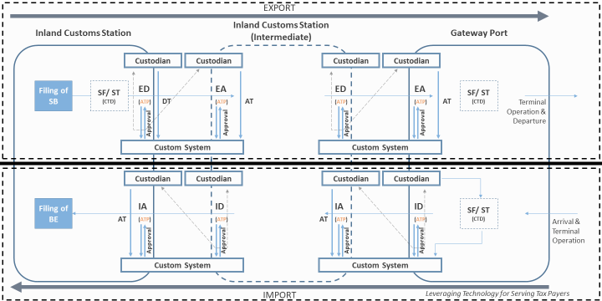

Manifest Master Object

4.1 JSON Objects:
  - Manifest Declaration
  - Master CIM
  - Master Location
  - Master TM
  - Master Events
  - Cargo Container
  - Cargo Document
  - Supporting Document
  - DigiSign

4.2 Structure – Hierarchy:

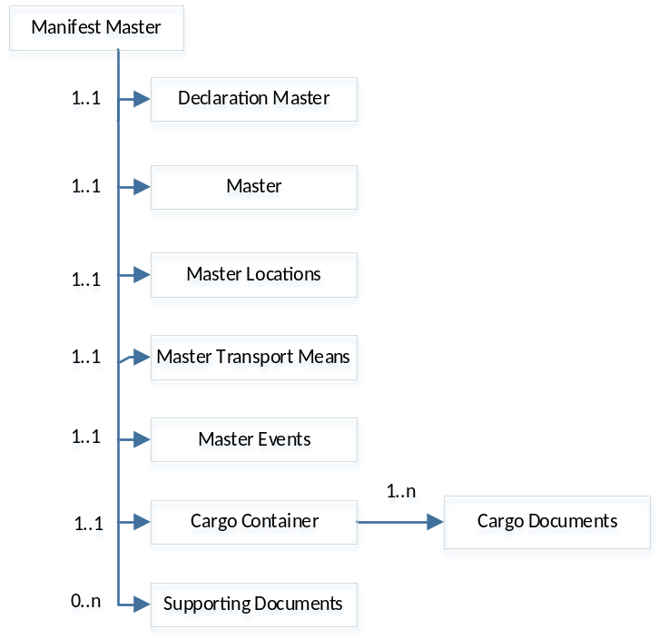

Attribute Table – Common structure

4.3.1 Manifest Master: Declaration

Object | Attribute Name | Data Type | Remarks | Pattern & Description
Declaration  ("declaration")  Required-true  1..1 | Message Type  ("messageType") | CHAR (1) | The Flag specifying the action requested on this transmission  LOV: F - Fresh  A - Amendment | Desc: Default Value - F
Declaration  ("declaration")  Required-true  1..1 | Port of Reporting  ("portOfReporting") | VARCHAR2 (10) | The Custom Location of Reporting | Pattern: ([I][N])([A-Z]|[0-9]){8}$
Declaration  ("declaration")  Required-true  1..1 | Job No.  (“jobNo”) | NUMBER (7) | The Unique ID provided by User for this transmission
Declaration  ("declaration")  Required-true  1..1 | Job Date  (“jobDate”) | DATE | Date of generation of unique id provided by user for this transmission | Pattern: ^[0-9]{4}(0[1-9]|1[0-2])(0[1-9]|[1-2][0-9]|3[0-1])$  Desc: YYYYMMDD
Declaration  ("declaration")  Required-true  1..1 | Reporting Event  ("reportingEvent") | CHAR (4) | The Code specifying the Reporting Event pertaining to this transmission  LOV:  SF - Stuffing Report  ST - Stripping Report  AT - Arrival Time  DT - Departure Time  CC - Communication to Custodian

4.3.2 Manifest Master: CIM

Object | Attribute Name | Data Type | Remarks | Pattern & Description
CIM  Required-true  0…1 | CIM No.  ("CIMNumber") | NUMBER (12) | The unique id generated by Custom for this compliance
CIM  Required-true  0…1 | CIM Date  ("CIMDate") | DATE | The date unique id generated by Custom for this compliance | Pattern: ^[0-9]{4}(0[1-9]|1[0-2])(0[1-9]|[1-2][0-9]|3[0-1])$  Desc: YYYYMMDD

4.3.3 Manifest Master: Location

Object | Attribute Name | Data Type | Remarks | Pattern & Description
Location  ("location")  Required-True  1..1 | Reporting Party Type  (reportingPartyType  ) | CHAR (7) | LOV:  EXP – Exporter,  C – Custodian,  T – Terminal Operators
Location  ("location")  Required-True  1..1 | Reporting party Code  (reportingPartyCode  ) | VARCHAR2 (15) | Custom Identification No. | Pattern: ^[a-zA-Z0-9]{10}$  Desc: 03 digit alphanumeric, like – CON, ADN
Location  ("location")  Required-True  1..1 | Reference Movement Type  ("referenceMovementType") | VARCHAR2 (2) | e-waybill / other movement | Pattern: ^[0-9]{12}$  Desc: EWAY Bill Flag
Location  ("location")  Required-True  1..1 | Reference Movement No.  ("referenceMovementNumber") | VARCHAR2 (35) | e-waybill no. / Movement No. | Desc: EWAY Bill Number -12 digit numeric, if EW
Location  ("location")  Required-True  1..1 | Reference Movement Date  ("referenceMovementDate") | DATE | e-waybill date / Movement date | Pattern: ^[0-9]{4}(0[1-9]|1[0-2])(0[1-9]|[1-2][0-9]|3[0-1])$  Desc: YYYYMMDD
Location  ("location")  Required-True  1..1 | Bond No.  (bondNumber) | VARCHAR2 (10) | Bond Number
Location  ("location")  Required-True  1..1 | Reporting Location Code  (reportingLocationCode) | VARCHAR2 (15) | Custodian Code | Pattern: ^([a-zA-Z ]|[0-9]){10}([0-9]{3})$  Desc: 10 digit alphanumeric
Location  ("location")  Required-True  1..1 | Reporting Location Name  (reportingLocationName) | VARCHAR2 (35) | Where stuffing took place | Desc: Branch Location
Location  ("location")  Required-True  1..1 | Next Destination of Unlading  (nextDestinationOfUnlading) | VARCHAR2 (10) | Custodian Code of next site | Pattern: ([I][N])([A-Z]|[0-9]){8}$  Desc: Destination Custodian Code 10 digit alphanumeric
Location  ("location")  Required-True  1..1 | Authorized Person PAN  (authorizedPersonPAN) | VARCHAR2 (10) | PAN No. of Authorized Person | Pattern: ^([a-zA-Z]){5}([0-9]){4}([a-zA-Z]){1}$

4.3.4 Manifest Master: Transport Means

Object | Attribute Name | Data Type | Remarks | Pattern/Description
Transport Means  Required – True  0…1 | Transport Means Type  ("transportMeansType") | CHAR (1) | Means of transport for this transmission  LOV: 1 – Sea, 2 – Rail, 3 – Truck, 4 - Air | Pattern: ^[a-zA-Z0-9]{1}$
Transport Means  Required – True  0…1 | Transport Means No.  ("transportMeansNumber") | VARCHAR2 (12) | Identification No. of train / license plate no. of truck | Desc: Truck or Trailer number | Rail number
Transport Means  Required – True  0…1 | Transport Means eID Type  ("transportMeanseIDType") | VARCHAR2 (4) | Fastag or any other type
Transport Means  Required – True  0…1 | Transport Means eID  ("transportMeanseID") | VARCHAR2 (16) | Fastag No. | Desc: RFID Tag number of vehicle
Transport Means  Required – True  0…1 | Total Equipment’s  ("totalEquipments") | NUMBER (4) | Total no. of transport equipment’s

4.3.5 Manifest Master: Events

Object | Attribute Name | Data Type | Description /Remarks | Sample
Events (“events”)  Required – True  1…1 | Expected Time of Departure  (“expectedTimeOfDeparture”) | TIMESTAMP | Date and Time of event | Pattern: ^[0-9]{4}(0[1-9]|1[0-2])(0[1-9]|[1-2][0-9]|3[0-1])[T]([0-1][0-9]|[2][0-3]):([0-5][0-9])$
Events (“events”)  Required – True  1…1 | Actual Time of Departure  (“actualTimeOfDeparture”) | TIMESTAMP | Date and Time of event | Pattern: ^[0-9]{4}(0[1-9]|1[0-2])(0[1-9]|[1-2][0-9]|3[0-1])[T]([0-1][0-9]|[2][0-3]):([0-5][0-9])$
Events (“events”)  Required – True  1…1 | Expected Time of Arrival  (expecteTimeOfArrival) | TIMESTAMP | Date and Time of event | Pattern: ^[0-9]{4}(0[1-9]|1[0-2])(0[1-9]|[1-2][0-9]|3[0-1])[T]([0-1][0-9]|[2][0-3]):([0-5][0-9])$
Events (“events”)  Required – True  1…1 | Actual Time of Arrival  (actualTimeOfArrival) | TIMESTAMP | Date and Time of event | Pattern: ^[0-9]{4}(0[1-9]|1[0-2])(0[1-9]|[1-2][0-9]|3[0-1])[T]([0-1][0-9]|[2][0-3]):([0-5][0-9])$

4.3.6 Manifest Master: Cargo Container

Object | Attribute Name | Data Type | Remarks | Pattern & Description
Cargo Container ("cargoContainer")  Required – True  1…n | Message Type  (“msgTyp”) | CHAR (1) | The Flag specifying the action requested on this transmission  LOV:  F - Fresh  A - Amendment | Desc: Default Value - F
Cargo Container ("cargoContainer")  Required – True  1…n | Equipment Sequence No.  ("equipmentSequenceNo") | NUMBER (5) | The Serial number of Equipment referenced in the Transport Document. Starting with 1
Cargo Container ("cargoContainer")  Required – True  1…n | Equipment ID  ("equipmentID") | VARCHAR2 (17) | Identification of container or truck no. in case of bonded truck  Marks (letters and/or numbers) which identify equipment e.g. unit load device, Container
Cargo Container ("cargoContainer")  Required – True  1…n | Equipment type ("equipmentType") | VARCHAR2 (3) | The Code specifying the type of the Equipment used for Transport  LOV:  CN - Container  B - Bonded truck  W – Wagon  CH – Chassis  DPL – Onboard Equipment,  TE - Trailer | Pattern: Pattern: ^[C][N]$|^[B]$|^[W]$|^[T][E]$|^[D][P][L]$|^[C][H]$|^[B][L]$|^[B][B]$
Cargo Container ("cargoContainer")  Required – True  1…n | Equipment Size  ("equipmentSize") | VARCHAR2 (4) | ISO code of container type | Pattern: ^[a-zA-Z0-9]$  Desc: 4 digit alphanumeric
Cargo Container ("cargoContainer")  Required – True  1…n | Equipment Load Status  ("equipmentLoadStatus") | CHAR (3) | Code specifying how full piece of transport is.  LOV: FCL - Full, LCL - Partial, EMP - Empty | pattern: ^[A-Z]$  Desc: FCL, LCL, EMP
Cargo Container ("cargoContainer")  Required – True  1…n | Additional Equipment Hold  ("additionalEquipmentHold") | VARCHAR2 (256) | Wagon No., Trailer No, coded  The Identifier for Additional Equipment used for Hold e.g Tray etc. | Desc: Wagon number incase of Rail
Cargo Container ("cargoContainer")  Required – True  1…n | Final Destination Location  (“finalDestinationLocation”) | VARCHAR2 (10) | Port Code of gateway port | Pattern: ([I][N])([A-Z]|[0-9]){8}$  Desc: 10 digit alphanumeric
Cargo Container ("cargoContainer")  Required – True  1…n | Event Date  (eventDate) | Date | Date and Time of event when cargo is being transported | Pattern: ^ [0-9]{4}(0[1-9]|1[0-2])(0[1-9]|[1-2][0-9]|3[0-1])$  Desc: Sealing Date
Cargo Container ("cargoContainer")  Required – True  1…n | Equipment seal Type  ("equipmentSealType") | CHAR (5) | Eseal / other type:  LOV:  E-Seal – ESEAL,  Bottle Seal - BTSL,  Other Seal - OTH | Pattern: ^[A-Z]$
Cargo Container ("cargoContainer")  Required – True  1…n | Equipment Seal No.  ("equipmentSealNumber") | CHAR (15) | No. of Equipment Seal | Pattern: "^[a-zA-Z0-9]$  Desc: a alphanumeric
Cargo Container ("cargoContainer")  Required – True  1…n | Other Equipment ID  ("otherEquipmentID”) | VARCHAR2 (256) | RFID tag or other Reference
Cargo Container ("cargoContainer")  Required – True  1…n | Equipment Status  (equipmentStatus”) | CHAR (3) | The Status of the Transport Equipment  Damaged  Intact  Short landed  Delay etc | Pattern: [a-zA-Z0-9]  Desc: value= 127
Cargo Container ("cargoContainer")  Required – True  1…n | Equipment Pkg  (equipmentPkg) | VARCHAR22) | Container  BULK
Cargo Container ("cargoContainer")  Required – True  1…n | Equipment Quantity  (equipmentQuantity) | NUMBER (16) | No. of container/pkg
Cargo Container ("cargoContainer")  Required – True  1…n | Equipment UQC  (equipmentUQC) | CHAR (3) | UQC Code  PKG - Package  KGS - Kilograms

4.3.7 Manifest Master: Cargo Details

Object | Attribute Name | Data Type | Remarks | Pattern & Description
Cargo Details ("cargoDetails")  Required – True  1…n | Message Type  ("messageType") | CHAR (1) | The Flag specifying the action requested on this transmission  F - Fresh  A - Amendment | Desc: Default value - F
Cargo Details ("cargoDetails")  Required – True  1…n | Cargo Sequence No.  (cargoSequenceNo) | NUMBER (4) | The serial No. indicating the cargo items carried I transport document
Cargo Details ("cargoDetails")  Required – True  1…n | Document Type  (documentType) | VARCHAR2 (4) | Identity the type of document  LOV:  PCIN - Primary Cargo Identification No.  MCIN - Master Cargo Identification No. | Pattern: "^[S][B]$|^[E][B][E]$|^[E][S][B]$|^[Z][S][B]$|^[M][S][B]$|^[M][B][E]$|^[Z][B][E]$|^[M][C][I][N]$|^[P][C][I][N]$"  Desc: like SB
Cargo Details ("cargoDetails")  Required – True  1…n | Document Site  (documentSite) | VARCHAR2 (6) | Indian port code where document issued | Pattern: "([I][N])([A-Z]|[0-9]){4}$
Cargo Details ("cargoDetails")  Required – True  1…n | Document No.  (documentNo) | NUMBER (7) | Identification No. of document such as: BE No., SB No., MCIN No., PCIN No.
Cargo Details ("cargoDetails")  Required – True  1…n | Document Date  (documentDate) | DATE | Date of document | Pattern: ^[0-9]{4}(0[1-9]|1[0-2])(0[1-9]|[1-2][0-9]|3[0-1])$
Cargo Details ("cargoDetails")  Required – True  1…n | Shipment Load Status  (“shipment LoadStatus”) | CHAR (3) | To indicate if all cargo pertaining to this SB is in this container (F-Full) or if it is loaded in multiple containers (P-Partial)  LOV: F-Full, P-Partial | Pattern: ^[P]$|^[F]$  Desc: Value = P or F
Cargo Details ("cargoDetails")  Required – True  1…n | Package Type  (packageType) | VARCHAR2 (2) | LOV:  P - Package  LB - Liquid Bulk  DB - Dry Bulk | Pattern: ^[P]$|^[L][B]$|^[D][B]$
Cargo Details ("cargoDetails")  Required – True  1…n | Quantity  (quantity) | NUMBER (16) | No. of Packages
Cargo Details ("cargoDetails")  Required – True  1…n | Packets From  (packetsFrom) | NUMBER (6) | Starting no. of quantity in the container
Cargo Details ("cargoDetails")  Required – True  1…n | Packets To  (packetsTo) | NUMBER (6) | Ending no of quantity in the container
Cargo Details ("cargoDetails")  Required – True  1…n | Pack UQC  (packUQC) | CHAR (3) | UQC of quantity  LOV:  PKG - package  KGS - kilograms
Cargo Details ("cargoDetails")  Required – True  1…n | MCIN / PCIN  (“mcinPcin”) | VARCHAR2 (20) | The unique Identifier issued by Customs for Transport Contract issued by Main line operator- Master Cargo Identification Number

4.3.8 Manifest Master: Supporting Document

Object | Attribute Name | Data Type | Remarks | Pattern & Description
Supporting Document ("supportingDocuments")  Required – True  0…n | Message Type  ("messageType") | CHAR (1) | The Flag specifying the action requested on this transmission.  LOV:  F - Fresh,  A - Amendment | Desc: Default value - F
 | Equipment Serial No.  ("equipmentSerialNumber") | NUMBER (5)
 | Document Serial no.  ("documentSerialNumber") | NUMBER (4) | Serial No. of document
 | Icegate User ID  ("icegateUserID") | CHAR (15) | Icegate ID of user who uploaded the supporting documents
 | IRN No.  ("IRNNumber") | NUMBER (14) | The unique reference no given by eSanchit on uploading of document
 | Document Reference No.  ("documentReferenceNumber") | CHAR (17) | The unique reference no. given by issue to this document.  Eg. Aadhaar No.
 | Document Type Code  ("documentTypeCode") | CHAR (6) | The identifier assigned by Custom to identify the type of document
 | Beneficiary Code  ("beneficiaryCode") | CHAR (35) | The identifier of beneficiary of this document  Eg. IEC, Custodian Code etc.

4.3.9 Manifest Master: DigiSign

Object | Attribute Name | Data Type | Remarks | Pattern & Description
Digi Sign ("digSign")  Required – True  1…1 | Signature  ("startSignature") | VARCHAR2 | Start Signature
Digi Sign ("digSign")  Required – True  1…1 | Certificate  ("startCertificate") | VARCHAR2 | Start Certificate
Digi Sign ("digSign")  Required – True  1…1 | Version  ("signerVersion") | VARCHAR2 | Signer Version

Object Attribute Table

Object | Attribute Name | CIM-SF | CIM-ST | CIM-DT | CIM-AT | CIM-SFCN | CIM-CC
Declaration |  | M | M | M | M | M | M
 | Message Type | M | M | M | M | M | M
 | Port of Reporting | M | M | M | M | M | M
 | Job No. | M | M | M | M | M | X
 | Job Date | M | M | M | M | M | X
 | Reporting Event | M  (SF) | M  (ST) | M  (DT) | M  (AT) | M  (SFCN) | M  (CC)
CIM |  | X | X | M | M | X | M
 | CIM No. |  |  | M | M |  | M
 | CIM Date |  |  | M | M |  | M
Location |  | M | M | M | M | M | M
 | Reporting Party Type | M | M | M | M | X | M
 | Reporting party Code | M | M | M | M | M | M
 | Reference Movement Type | X | X | O | O | X | O
 | Reference Movement No. | X | X | O | O | X | O
 | Reference Movement Date | X | X | O | O | X | O
 | Bond No. | X | X | X | X | X | M
 | Reporting Location Code | M | M | M | M | M | M
 | Reporting Location Name | M | M | O | O | X | X
 | Next Destination of Unlading | X | X | M | M | X | M
 | Authorized Person PAN | M | M | M | M | M | M
Transport Means |  | X | X | M | M | X | M
 | Transport Means Type |  |  | M | M |  | M
 | Transport Means No. |  |  | M | M |  | M
 | Transport Means eID Type |  |  | O | O |  | O
 | Transport Means eID |  |  | O | O |  | O
 | Total Equipment’s |  |  | M | M |  | M
Events |  | X | X | M | M | X | M
 | Expected Time of Departure |  |  | X | X |  | O
 | Actual Time of Departure |  |  | M | X |  | O
 | Expected Time of Arrival |  |  | X | X |  | O
 | Actual Time of Arrival |  |  | X | M |  | O
Cargo Container |  | M | M | M | M | M | M
 | Message Type | M | M | M | M | X | M
 | Equipment Sequence No. | M | M | M | M | X | M
 | Container ID | M | M | M | M | M | M
 | Equipment type | M | M | M | M | X | M
 | Equipment Size | M | M | M | M | X | M
 | Equipment Load Status | M | M | X | X | X | M
 | Additional Equipment Hold | O | O | X | X | X | O
 | Final Destination Location | M | M | X | X | X | O
 | Event Date | M | M | X | X | X | O
 | Equipment seal Type | M | M | X | X | X | O
 | Equipment Seal No. | M | M | X | X | X | O
 | Other Equipment ID | O | O | X | X | X | O
 | Equipment Status | M | M | X | X | X | M
 | Equipment Pkg | O | O | X | X | X | O
 | Equipment Quantity | M | M | X | X | X | O
 | Equipment UQC | O | O | X | X | X | O
Cargo Details |  | M | M | X | X | M | X
 | Message Type | M | M |  |  | X
 | Equipment Id | X | X | X | X | M | X
 | Cargo Sequence No. | M | M |  |  | X
 | Document Type | M | M |  |  | X
 | Document Site | M | M |  |  | X
 | Document No. | O | O |  |  | X
 | Document Date | O | O |  |  | X
 | Shipment Load Status | M | M |  |  | X
 | Package Type | M | M |  |  | X
 | Quantity | M | O |  |  | X
 | Packets From | M | O |  |  | X
 | Packets To | M | O |  |  | X
 | Pack UQC | M | M |  |  | X
 | MCIN / PCIN | M | M |  |  | M
Supporting Document |  | O | O | O | O | X | O
 | Message Type | M | M | O | O |  | O
 | Equipment Serial No. | M | M | M | M |  | M
 | Document Serial no. | M | M | M | M |  | M
 | Icegate User ID | M | M | M | M |  | M
 | IRN No. | M | M | M | M |  | M
 | Document Reference No. | M | M | M | M |  | M
 | Document Type Code | M | M | M | M |  | M
 | Beneficiary Code | O | O | O | O |  | O

JSON Schema and Samples

Inbound JSON Schema

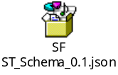

Inbound JSON Samples

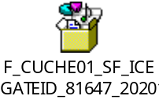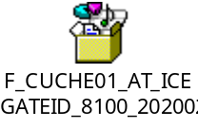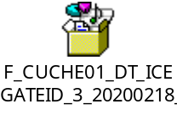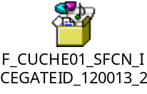

Outbound SFL JSON Schema



Outbound SFL JSON Samples

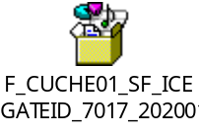

Outbound ACK JSON Schema



Outbound ACK JSON Samples



List of Values

Object Name | Description | Code
Message Type | Fresh | F
Message Type | Amendment | A
Indicator | Production | P
Indicator | Test | T
Reporting Event | Stuffing Report | SF
Reporting Event | Stripping Report | ST
Reporting Event | Arrival Time | AT
Reporting Event | Departure Time | DT
Reporting Event | Communication to Custodian | CC
Reporting Party Type | Exporter | EXP
Reporting Party Type | Custodian | C
Reporting Party Type | Terminal Operators | T
Transport Means Type | Sea | 1
Transport Means Type | Rail | 2
Transport Means Type | Truck | 3
Transport Means Type | Air | 4
Equipment type | Container | C
Equipment type | Bonded truck | B
Equipment type | wagon | W
Package Type | Packaged | P
Package Type | Liquid Bulk | LB
Package Type | Dry Bulk | DB
Equipment Load Status | Partial | LCL
Equipment Load Status | Empty | EMP
Equipment Load Status | Full | FCL
Equipment Seal Type | E-Seal | ESEAL
Equipment Seal Type | Bottle Seal | BTSL
Equipment Seal Type | Other Seal | OTH
Equipment QUC | Package | PKG
Equipment QUC | Kilograms | KGS
Document Type | Entry Bill | EBE – EDI BE,  ZBE – SEZ BE,  MBE – Manual BE
Document Type | Shipping Bill | ESB - EDI SB,  ZSB - SEZ SB,  MSB – Manual SB
Document Type | Primary Cargo Identification No. | PCIN
Document Type | Master Cargo Identification No. | MCIN
Shipment Load Status | Full | F
Shipment Load Status | Partial | P

Code List: Equipment Status and Equipment Type
Code_Type | Code | Code Name
Equ_Status | 001 | Arrival, completed
Equ_Status | 3 | Arrival, in defective condition
Equ_Status | 15 | Consolidated
Equ_Status | 16 | Crossed border
Equ_Status | 18 | Damaged in the course of transportation
Equ_Status | 35 | Forwarded to destination
Equ_Status | 208 | Seals, replaced
Equ_Status | 218 | Damaged
Equ_Status | 238 | Means of transport, damaged
Equ_Status | 309 | Packaging/equipment opened
Equ_Status | 335 | Seals, damaged
Equ_Status | 336 | Seals, broken
Equ_Status | 337 | Seals, tampered
Equ_Status | 127 | Departed, completed on a means of transport
Equ_Status | 94 | Stuffed and sealed
Equ_Status | 71 | Ready for transportation
EQU_Type | BB | Breakbulk
EQU_Type | BL | Blocks
EQU_Type | CH | Chassis
EQU_Type | CN | Container
EQU_Type | DPL | Onboard Equipment
EQU_Type | TE | Trailer
EQU_Type | B | Bonded truck
EQU_Type | W | wagon

Error Code List

ACU SF Message

Error Code | Description (Message Level)
M 01 | Duplicate record in master table
CCM 02 | Duplicate record in Container
CDM 03 | Duplicate record in cargo
SDM 04 | Duplicate record in Supporting Document
M 05 | Master record Is missing
Error Code | Description (Business level)
HFB02 | Invalid Reporting event Valid values are (SF,ST,AT,DT)
LCB03 | Party type Should be ‘C’- Custodian
CDB04 | Mandatory mcin/pcin is missing
CDB05 | PCIN is not valid
CDB06 | Shipping Bill is not ready for ‘Stuffing’
CDB07 | Stripping message is not received for cargo
CDB08 | Number of packages are more than declared in SB
CDB09 | Cargo is not available at reporting site for stuffing
CDB10 | Invalid package range
CDB11 | Package is already stuffed
LCB12 | Party Type is not valid
LCB13 | Party Code is not valid
LCB14 | Authorized Person PAN is not valid
CCB15 | Only one container is allowed per stuffing message
CDB15  CDB16 | Package numbers are not correct  Stuffing package details do not tally with the shipping bill package details.
CCB16 | Container is already stuffed
CDB18 | Shipment Type is not valid
CDB19 | Shipment Type is not valid for all records for PCIN
CDB20 | Custodian Code is not valid

ACU SFCN Message

Error Code | Description (Message Level)
M 01 | Duplicate record in master table
CCM 02 | Duplicate record in Container
CDM 03 | Duplicate record in cargo
M 05 | Master record Is missing
Error Code | Description (Business level)
HFB02 | Invalid Reporting event Valid values are (SF,ST,AT,DT,SFCN)
LCB03 | Party type Should be ‘C’- Custodian
LCB04 | Location code is not valid
CDB05 | PCIN is not valid
CDB22 | Stuffing message is not received for container
CDB23 | Party code is not valid
CDB24 | Container is not available at reporting site for stuffing Cancellation
CDB25 | Authorized Person PAN is not valid
CDB28 | CIN is not ready for Stuffing Cancellation
CDB29 | Container No. not matched with the container No.given in Stuffing.
LCB12 | Party Type is not valid
CDB26 | Shipping Bill is not ready for Stuffing Cancellation
CDB27 | ASR message is not received for SB

ACU DT Message

Error code Description
HFB02 Invalid Reporting Event
LCB12 Party type is null
LCB13 Party Code is null
LCB14 Invalid authorized pan
LCB03 Invalid Party type
CIB01 DP Message is not yet received
CIB02 DT message is already received
TMB01 Mismatch between transport Number between DP and DT
TMB02 Mismatch between transport type between DP and DT
TMB03 Container available in DP but not in DT ie Container missing in DT
CCB01 Additional container in DT which is not available in DP

HF – Header Field Object, LC - Location Object, DC – Declaration Object, CD – Cargo Details Object, CC – Cargo Container Object, SD – Supporting Documents Object

Key Fields Table for Outbound File

Object | Attribute Name | Key Field (SF, ST) | Key Field (SFCN) | Key Field (AT, DT) | CIM-CC
Declaration |  | M | M | M | M
 | Message Type | M | M | M | M
 | Port of Reporting | M | M | M | M
 | Job No. | M | M | X | X
 | Job Date | M | M | X | X
 | Reporting Event | M | M | M | M
CIM |  | X | X | M | M
 | CIM No. |  |  | M | M
 | CIM Date |  |  | M | M
Location |  | M | M | M | M
 | Reporting Party Type | M | X | M | M
 | Reporting party Code | M | M | M | M
 | Reference Movement Type | X | X | X | X
 | Reference Movement No. | X | X | X | X
 | Reference Movement Date | X | X | X | X
 | Bond No. | X | X | X | X
 | Reporting Location Code | X | M | X | X
 | Reporting Location Name | X | X | X | X
 | Next Destination of Unlading | X | X | X | X
 | Authorized Person PAN | X | M | X | X
 | Error Code | M | M | M | M
Transport Means |  | X | X | M | M
 | Transport Means Type |  |  | M | M
 | Transport Means No. |  |  | M | M
 | Transport Means eID Type |  |  | X | X
 | Transport Means eID |  |  | X | X
 | Total Equipment’s |  |  | X | X
 | Error Code |  |  | M | M
Events |  | X | X | M | M
 | Expected Time of Departure |  |  | X | X
 | Actual Time of Departure |  |  | X | X
 | Expected Time of Arrival |  |  | X | X
 | Actual Time of Arrival |  |  | X | X
 | Error Code |  |  | M | M
Cargo Container |  | M | M | M | M
 | Message Type | M | X | M | M
 | Equipment Sequence No. | M | X | M | M
 | Container ID | M | M | M | M
 | Equipment type | X | X | X | X
 | Equipment Size | X | X | X | X
 | Equipment Load Status | X | X | X | X
 | Additional Equipment Hold | X | X | X | X
 | Final Destination Location | X | X | X | X
 | Event Date | X | X | X | X
 | Equipment seal Type | X | X | X | X
 | Equipment Seal No. | X | X | X | X
 | Other Equipment ID | X | X | X | X
 | Equipment Status | X | X | X | X
 | Equipment Pkg | X | X | X | X
 | Equipment Quantity | X | X | X | X
 | Equipment QUC | X | X | X | X
 | Error Code |  | X
Cargo Details |  | M | M | X | X
 | Message Type | M | X
 | Equipment ID | X | M
 | Cargo Sequence No. | M | X
 | Document Type | X | X
 | Document Site | X | X
 | Document No. | X | X
 | Document Date | X | X
 | Shipment Load Status | X | X
 | Package Type | X | X
 | Quantity | X | X
 | Packets From | X | X
 | Packets To | X | X
 | Pack UQC | X | X
 | MCIN / PCIN | X | M
 | Error Code | M | M
Supporting Document |  | O | X | O | O
 | Message Type | M |  | M | M
 | Equipment Serial No. | M |  | M | M
 | Document Serial no. | M |  | M | M
 | Icegate User ID | X |  | X | X
 | IRN No. | X |  | X | X
 | Document Reference No. | X |  | X | X
 | Document Type Code | X |  | X | X
 | Beneficiary Code | X |  | X | X
 | Error code | M |  | M | M

