Date: 05 December 2022 Advisory No: 18/2022

Category: Imports (National Transshipment Bond), Customs

Issued by: DGoS, ICEGATE

**Subject: Implementation of All India Air Transhipment Message fillings for Air to Air and Air to ICD Transhipment in imports at ICEGATE**

1. CBIC has enabled filing of Air Transshipment (ATP) messages on ICEGATE, where registered users can file the ATP EDI messages via Email or Web Upload. User is advised to use .IN or .in as a file extension.
2. This is exclusively for Air-to-Air module. Following messages have been made live Air Tran-shipment module: -

|  |  |  |  |
| --- | --- | --- | --- |
| **Message Id** | **Message type** | **Source** | **Destination** |
| ALCHI03 | Fresh | Airlines | Custom House |
| ALCHI05 | Fresh | Airline | Custom House |
| CHALI03 | Fresh | Custom House | Airline |
| CHALI05 | Fresh | Custom House | Airline |
| CHALI04 | Fresh | Custom House | Airline |
| CHALI06 | Fresh | Custom House | Airline |
| ALCHI03 | Cancellation | Airline | Custom House |
| ALCHI05 | Cancellation | Airline | Custom House |
| CHALI03 | Cancellation | Custom House | Airline |
| CHALI05 | Cancellation | Custom House | Airline |
| CHALI04 | Cancellation | Custom House | Airline |
| CHALI06 | Cancellation | Custom House | Airline |

1. **Business Process Flow: -**

Process Flow and Message Exchange Specifications for Transshipment Application for Air sites is as follows:

1. Filing of Cargo Transfer Manifest (CTM) at Service Center/ICEGATE
2. Cargo Transfer Manifest (CTM) Approval in ICES
3. Request for Cancellation of Cargo Transfer Manifest (CTM)
4. Approval of CTM Cancellation Request in ICES
5. Filing of Transshipment Permit (TP) Request at Service Center/ICEGATE
6. TP Approval in ICES
7. Request for Cancellation of TP by Transshipment Agency
8. Approval of TP Cancellation by Customs
9. Post-TP Cargo Loading and Sealing
10. Gate-in Process at destination Air/ICD Site
11. Below steps can be followed by users to avail file upload functionality.

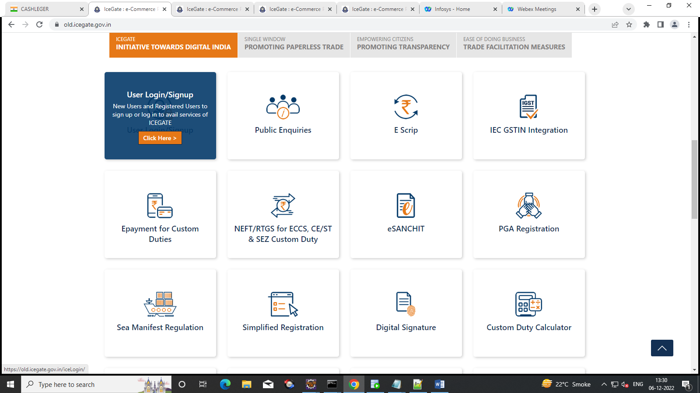

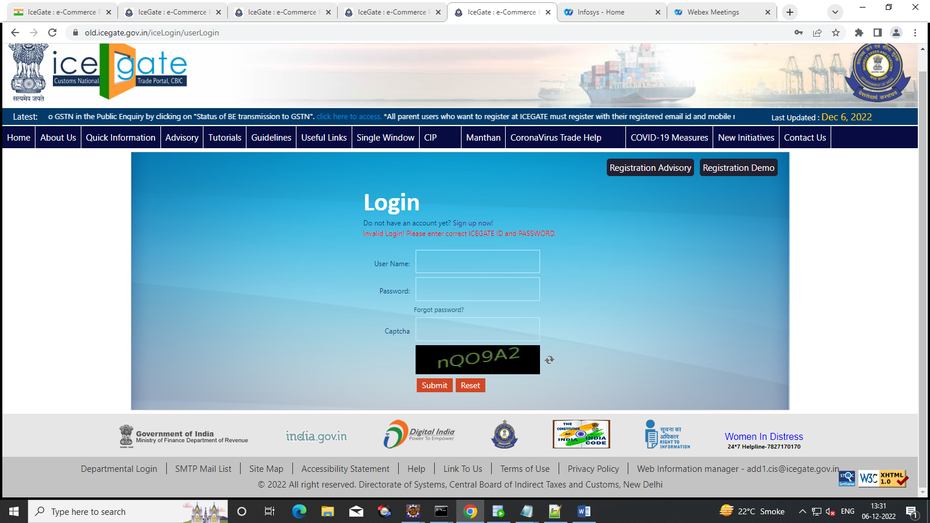

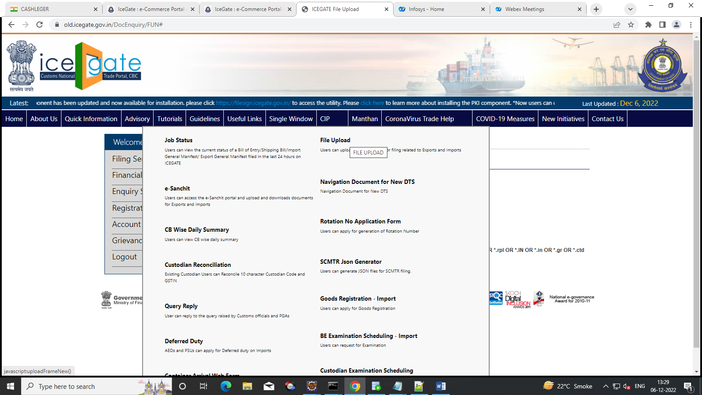

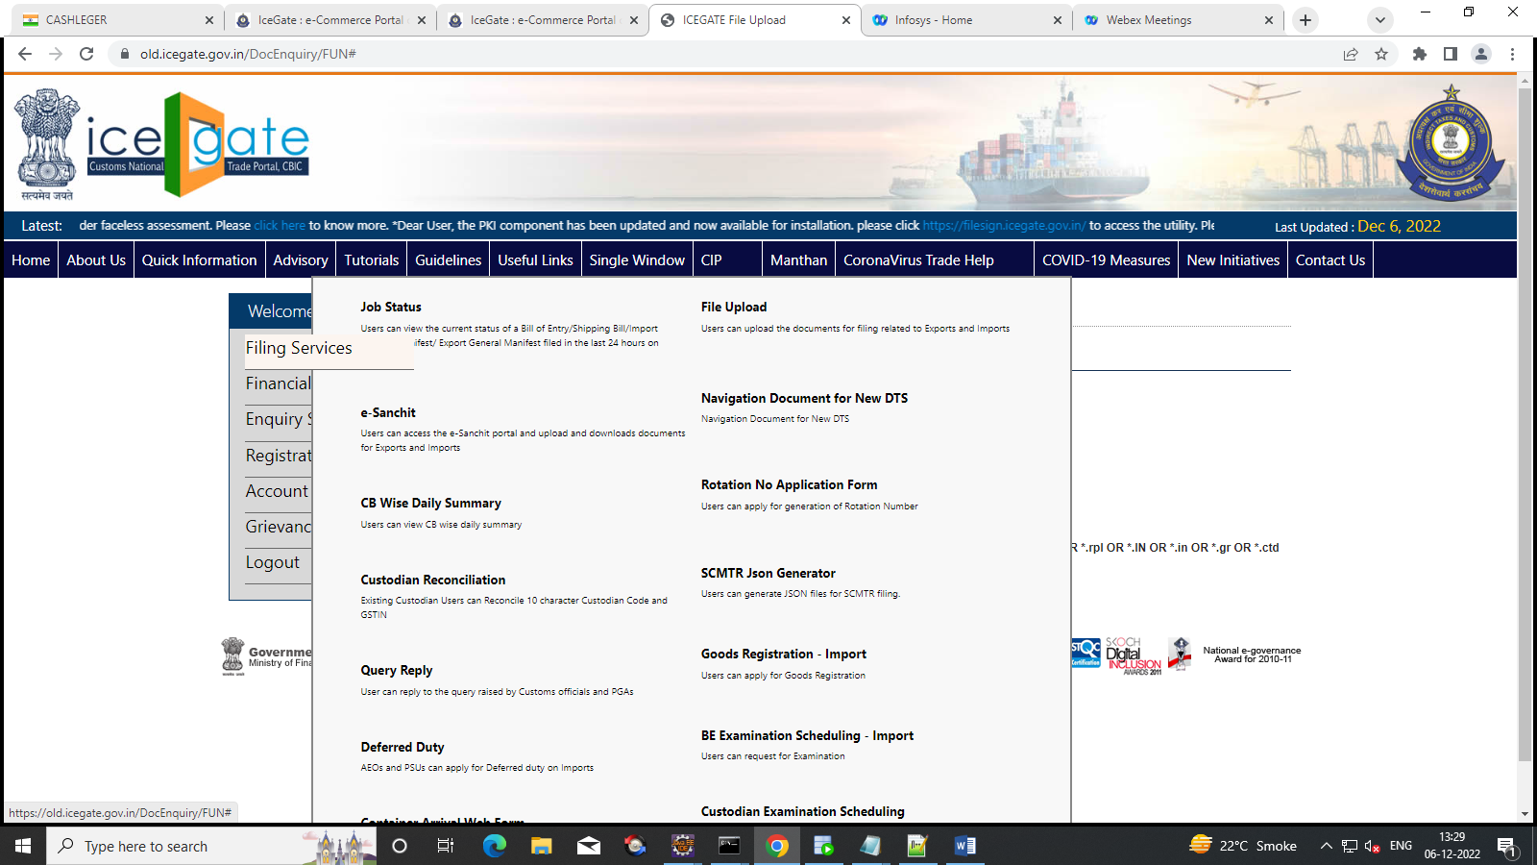

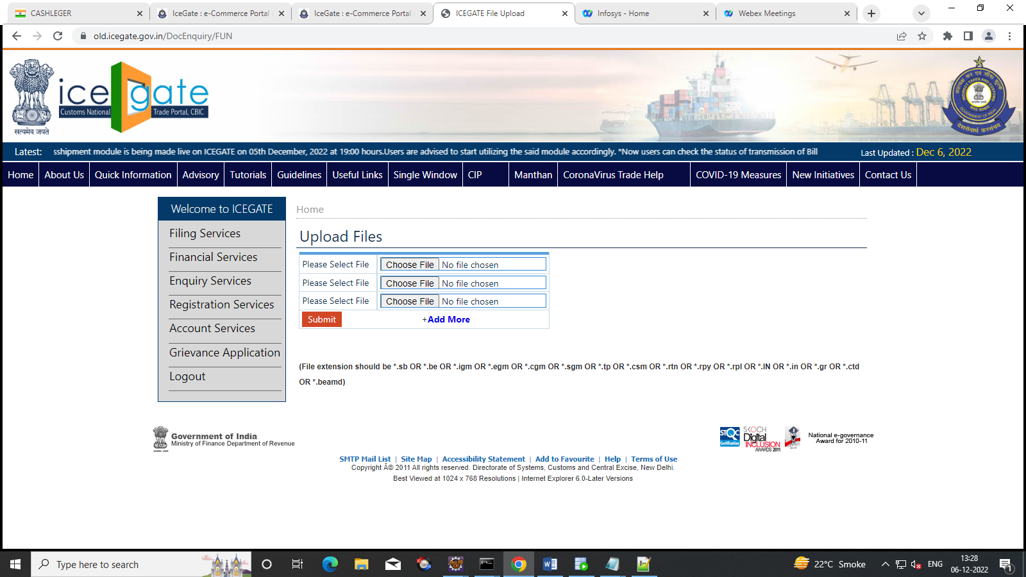

1. Users can also avail functionality for filing ATP message via SMTP route. Users are requested to refer below link for SMTPmail list for respective location. <https://old.icegate.gov.in/SMTPList.html>

For User convinience Sample file are provided below.The same can be referred for filing purpose.

|  |  |  |
| --- | --- | --- |
| **Description** | **Sample Files** | **Annexure for Fresh and Cancel** |
| Fresh Cargo Transfer Manifest (CTM) Request (2-part message) |  |  |
| Cancel Cargo Transfer Manifest (CTM) Request (2-part message) |  |
| Fresh Transshipment Permit (TP) Request (3-part message) |  |  |
| Cancel Transshipment Permit (TP) Request (3-part message) |  |

1. For any further queries or help kindly contact ICEGATE Helpdesk Team on icegatehelpdesk@icegate.gov.in or 1800-3010-1000